Geiger-Müller counter – results form

Measurement of the Geiger-Müller tube characteristics

U  [V] | N  [imp/s]
320 | 0
U₀
340
350
360
380
400
450
500
550
600
650

U₀ =

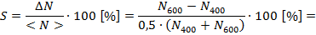

- graph – the dependency of the measured impulse rate on the GM tube voltage

Measurement of the dependence of the impulse rate on the distance between the source of the radiation and the detector

r  [cm] | N  [imp/s] |  |  | N_{PR}  [imp/s] | N_{PR}- N₀  [imp/s]
2
3
4
5
6
7
8
9
10

N₀
[imp/s]

- graph + regression curve

