Electrocardiography and Cardiomonitoring

Results:

ECG record - see attachment

Duration of important parts of ECG cycle
Record at rest
n | Interval R-R |  | Interval P-Q | Complex QRS | Interval P-S | Interval Q-T | Interval S-T
1
2
3
4
5
mean
beats/min
Record after exercise
n | Interval R-R | Interval P-Q | Complex QRS | Interval P-S | Interval Q-T | Interval S-T
1
2
3
4
5
mean
 | beats/min
change | % | % | % | % | % | %

Mean difference between R and S size and the electrical heart axis direction:

Lead I | Lead II | Lead III

Lead I
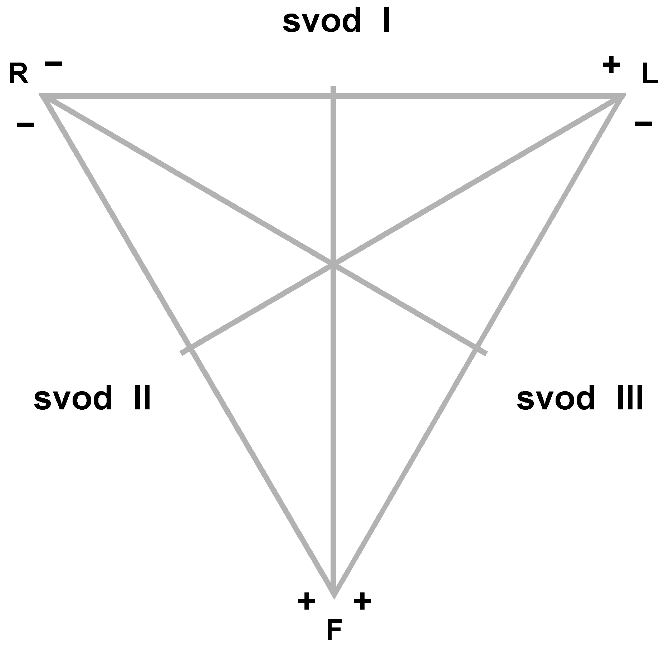
Lead II
Lead III

